How different crimes are happening in Houston area of US has been shown using an interactive dashboard from Shiny R. Below is the example of how it looks in the application.

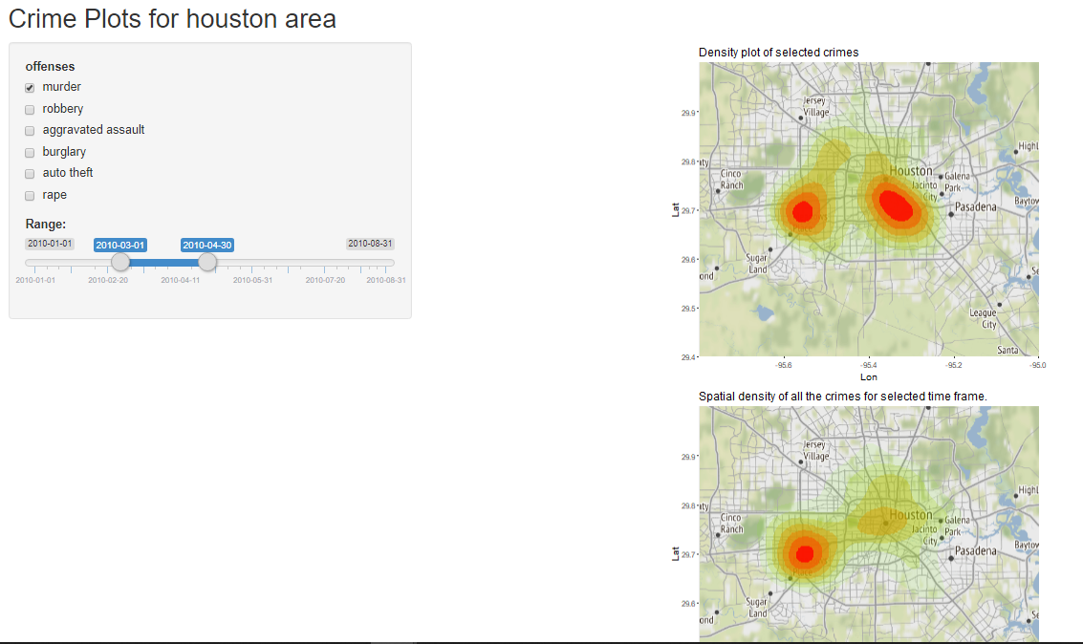

Here map of Houston has been used where density plot for the selected offence type has been shown in the first map and spatial density of all the crimes for the selected time frame has been derived in the second graph. coloring has been done to differentiate density of the crime where dark red means crime rate too much high and yellow means less crime. Users can select their desired one or more offence type to see and also can select the time frame for which they want to see all crimes. Appropriate titles for every graph, every sidebar panel and axis labels have been shown.